INF 354 Group Assignment

Deliverable 1 Documentation

Gabriella Rossi - u16084030

Alana Sinclair - u16255977

Jake Rawlinson – u

Kyle Olivier – u15001319

Jared van Harn - u17033277

# 1. Value Proposition

# 2. Entity Relationship Diagram for Proposed Solution

# 3. High-level Requirements

## 3.1. API Requirements

|  |  |
| --- | --- |
| Requirement/Function | Description |
| 1. Post Specialist Login Details Request | The API should be able to post the Specialist’s login details. |
| 2. Post Specialist Details Request | The API should be able to post the specialist details. |
| 3. Post Subtypes List Request | The API should be able to post a list of Subtypes. |
| 4. Post Causes List Request | The API should be able to post a list of causes. |
| 5. Post Preventions List Request | The API should be able to post a list of preventions. |
| 6. Post Supplies List Request | The API should be able to post a list of Supplies |
| 7. Post Symptoms List Request | The API should be able to post a list of Symptoms. |
| 8. Post Treatments List Request | The API should be able to post a list of Treatments. |
| 9. Post Active Areas List Request | The API should be able to post a list of Active Areas. |
| 10. Post Outbreaks List Request | The API should be able to post a list of Outbreaks. |
| 11. Get Disease Request | The API should be able to request a disease. |
| 12. Get Subtypes Request | The API should be able to request a subtype. |
| 13. Get Causes Request | The API should be able to request a cause. |
| 14. Get Preventions and Supplies Request | The API should be able to request Supplies and Preventions. |
| 15. Get Symptoms and Treatments Request | The API should be able to request Symptoms and treatments. |
| 16. Get Active Areas and Outbreaks Request | The API should be able to request Active Areas and Outbreaks. |
| 17. Get Specialists Request | The API should be able to request a Specialist. |

## 3.2. Administrative Back-end Requirements

|  |  |
| --- | --- |
| Requirement/Function | Description |
| 1. Add Specialist Account | This will add an account for a specialist, who will be using the app. |
| 2. View Specialist Account Details | This will display the details relative to the Specialist. |
| 3. Update Specialist Account Details | This allows Specialist details to be updated. |
| 4. Delete Specialist Account Details | This will delete the Specialist |
| 5. Log In | Allows the Specialist to log in and start using the app. |
| 6. Log Out | This allows the Specialist to log out of the app. |
| 7. Add New Subtype | This will allow the Specialist to add a new Subtype of the chosen disease, Malaria. |
| 8. View Subtypes | This will allow for the viewing of the Subtypes relative to Malaria. |
| 9. Update Subtype | This will allow the Specialist to update the details of the Subtype. |
| 10. Delete Subtype | This allows the Specialist to delete a subtype. |
| 11. Add New Cause | The Specialist will be able to add a new Cause of the chosen disease, Malaria. |
| 12. View Causes | This will display the Causes and details thereof. |
| 13. Update Cause | This allows the Specialist to update the details of a cause. |
| 14. Delete Cause | This will allow the Specialist to delete a cause. |
| 15.Add New Prevention | This allows the Specialist to add a new Prevention of the disease. |
| 16. View Preventions | This will display the Preventions and details thereof. |
| 17. Update Prevention | This will allow the Specialist to update the details of a Prevention. |
| 18. Delete Prevention | This will allow the Specialist to delete a Prevention. |
| 19. Add New Supply | This allows the Specialist to add a new Supply, that may be needed for the prevention of Malaria. |
| 20. View Supplies | This allows the Specialist to view a list of Supplies. |
| 21. Update Supply | This allows the Specialist to update details of a specific Supply Item. |
| 22. Delete Supply | This allows the Specialist to delete a Supply item. |
| 23. Add New Symptom | This allows the Specialist to add a new Symptom of Malaria. |
| 24. View Symptoms | This allows the Specialist to view a list of Symptoms and details thereof. |
| 25. Update Symptom | This allows the Specialist to update details of a Symptom. |
| 26. Delete Symptom | This will allow the Specialist to delete a Symptom. |
| 27. Add New Treatment | This will allow the Specialist to add a new Treatment. |
| 28. View Treatments | This will allow the Specialist to view a list of treatments and details thereof. |
| 29. Update Treatment | This will allow the Specialist to update details of a Treatment. |
| 30. Delete Treatment | This will allow the Specialist to delete a Treatment. |
| 31. Add New Active Area | This will allow the Specialist to add an Active Area; explaining where the disease is active. |
| 32. View Active Areas | This will allow the Specialist to view a list of Active Areas. |
| 33. Update Active Area | This will allow the Specialist to update details of an Active Area. |
| 34. Delete Active Area | This will allow the Specialist to delete an Active Area. |
| 35. Add New Outbreak | This will allow the Specialist to add a new Outbreak. |
| 36. View Outbreaks by Active Area | This will allow the Specialist to view outbreaks relative to an Active Area. |
| 37. Update Outbreak | This will allow the Specialist to update the details of an Outbreak. |
| 38. Delete Outbreak | This will allow the Specialist to delete an outbreak. |

## 3.3. Mobile App Requirements

|  |  |
| --- | --- |
| Requirement/Function | Description |
| 1. Search Subtypes | This will allow the mobile app user to search for a subtype of the disease. |
| 2. View Subtypes | This will allow the mobile app user to view the subtypes of the disease. |
| 3. Search Causes | This will allow the mobile app user to search for a cause. |
| 4. View Causes | This will allow the mobile app user to view the causes. |
| 5. Search Preventions | This will allow the mobile app user to search Preventions. |
| 6. Search Supplies | This will allow the user to search Supplies. |
| 7. View Preventions and Supplies | This will allow the user to View Preventions and Supplies that relate to Preventions. |
| 8. Search Symptoms | This will allow the user to Search for Symptoms on the app. |
| 9. Search Treatments | This will allow the mobile app to search for Treatments of the disease on the app. |
| 10. View Symptoms and Treatments | This will allow the user to view the Symptoms and Treatments of the app. |
| 11. Search Active Areas | This will allow the User to search for Active Areas. |
| 12. Search Outbreaks | This will allow the user to search for outbreaks of the disease. |
| 13. View Active Areas and Outbreaks | This will allow the user to view active areas and outbreaks. |
| 14. Search Specialists | This will allow the user to search for specialists. |
| 15. View Specialists | This will allow the user to view specialists. |

# 4. Mock Up Views for Mobile App

Home Screen:

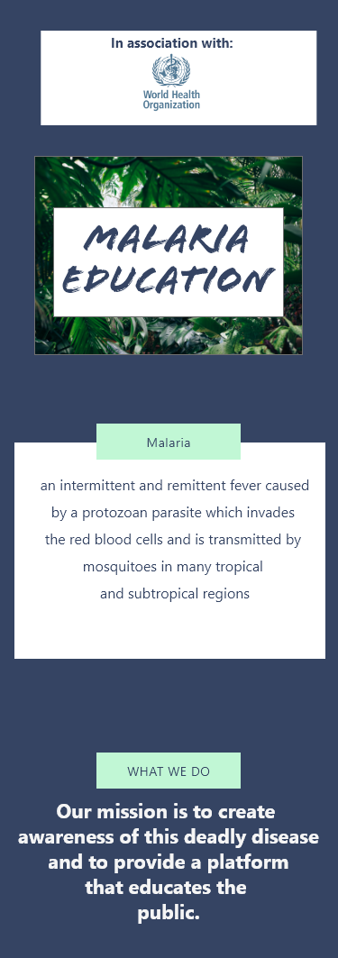

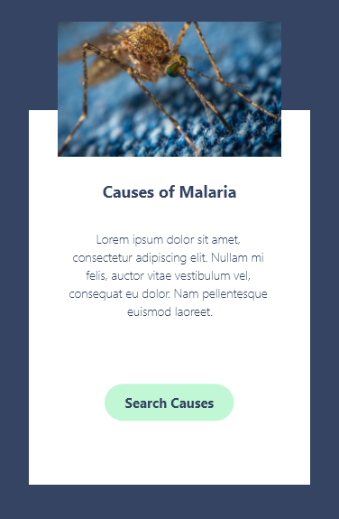

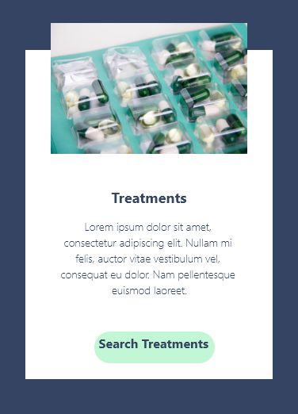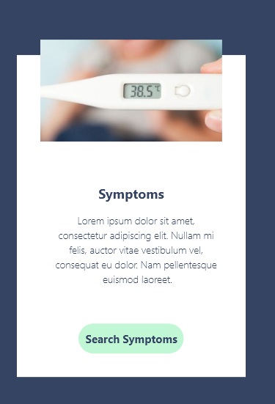

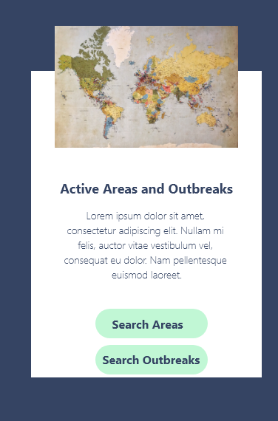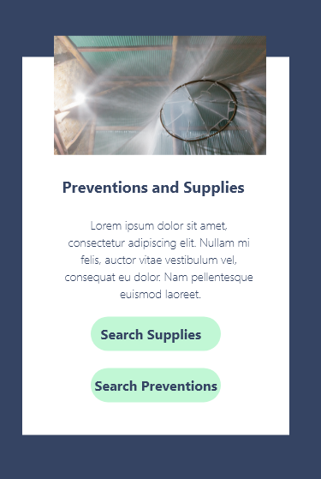

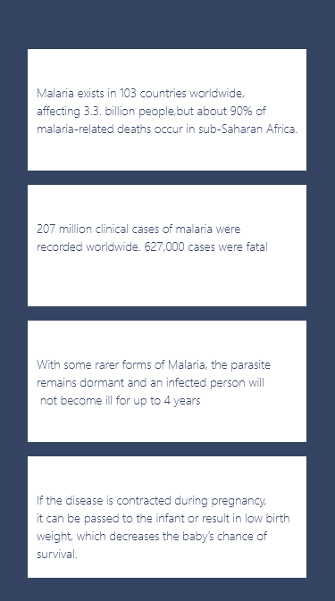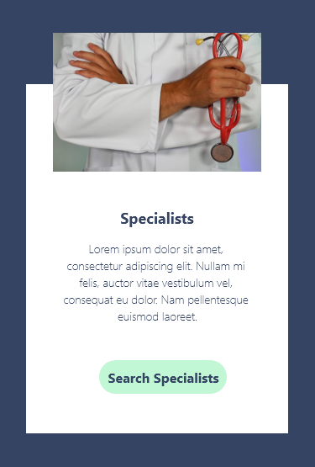

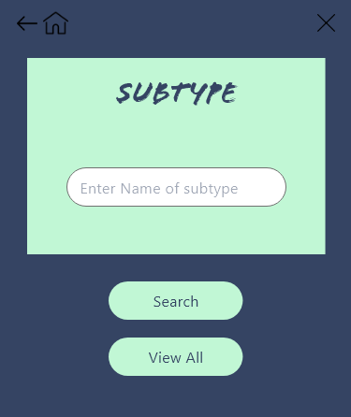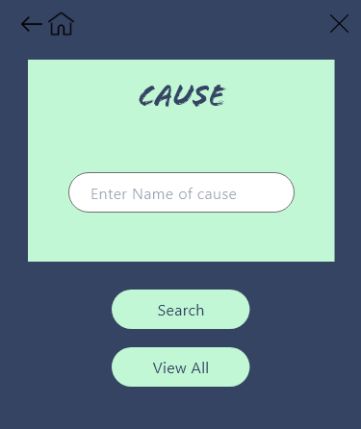Search Screens:

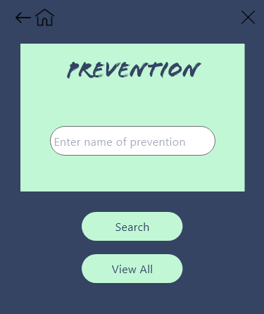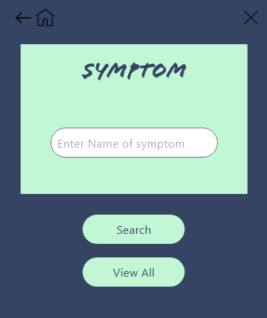

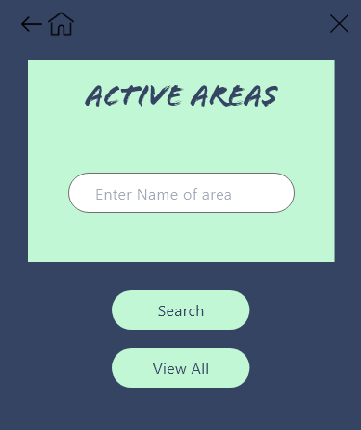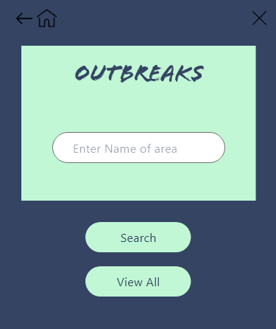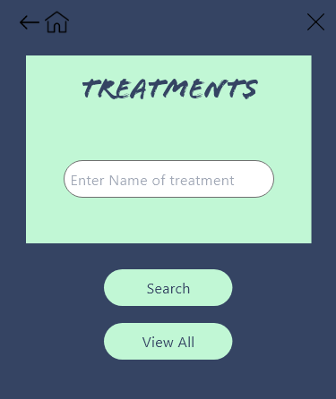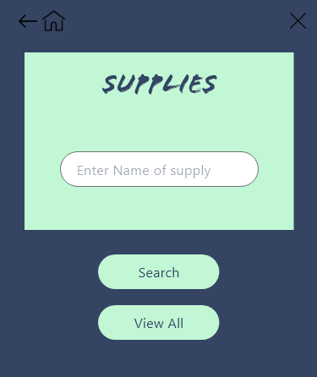

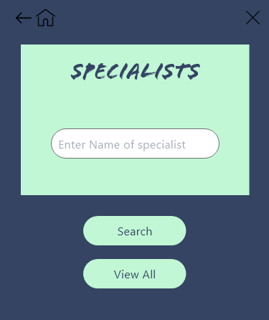

Search Results Screens:

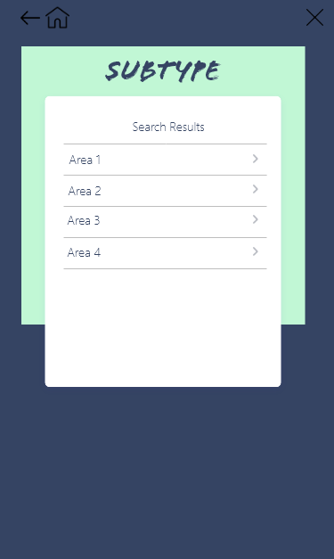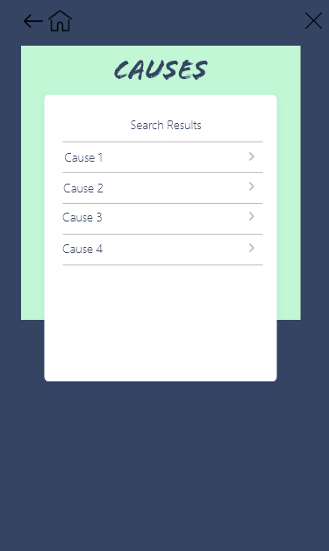

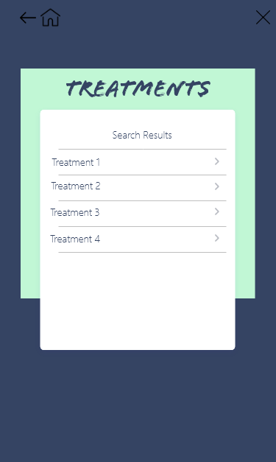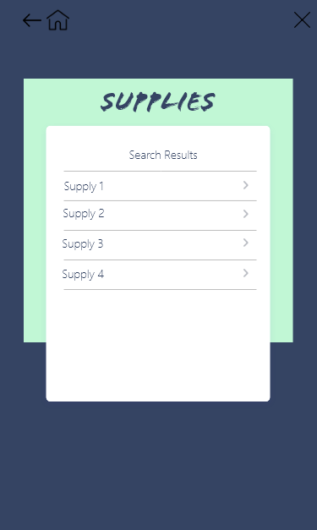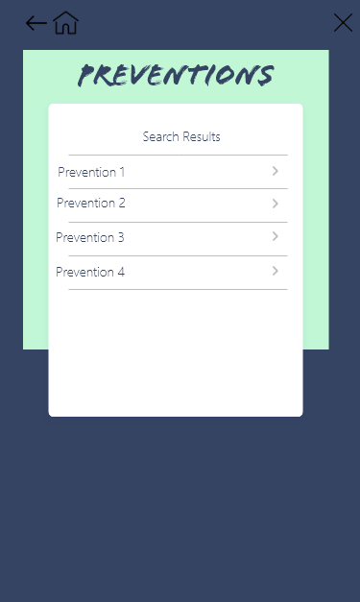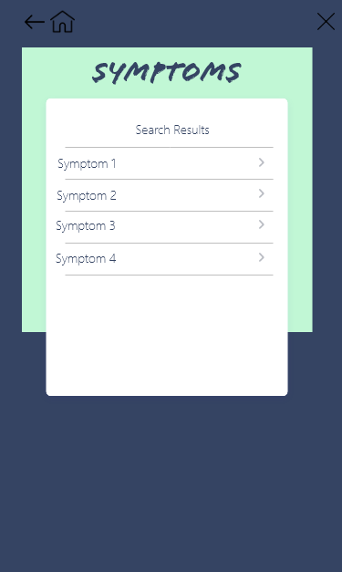

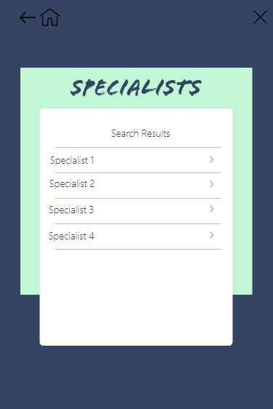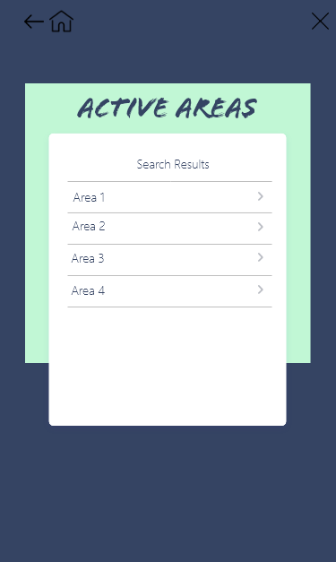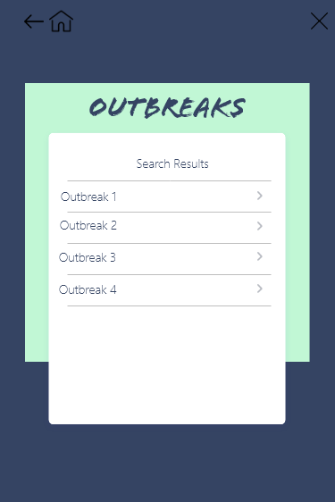

Details

